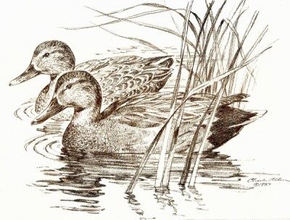
GRAFTON UNDERWOOD PARISH COUNCIL

Clerk: Mrs Ruby Cole
32 Old Road Tel: 07881 458801 / 01604 781834
Walgrave
Northampton E-mail : clerkgupc@gmail.com
NN6 9QW www.graftonunderwoodparishcouncil.com

Date: 16th September 2021
To: All Parish Councillors
From: Mrs R Cole, Clerk to Grafton Underwood Parish Council

Dear Councillor,
You are hereby summoned to attend the Extraordinary meeting of Grafton Underwood Parish Council to be held on Wednesday 22nd September 2021 at 7.00pm at Grafton Underwood Village Hall, when the under mentioned business will be transacted.
AGENDA

21/079 | Chairman: To elect a chairman of Grafton Underwood Parish Council.
21/080 | Apologies: To receive and approve apologies for absence.
21/081 | Public address to the council: Members of the public are invited to address the council. The session will last for a maximum of 15 minutes with any individual contribution lasting a maximum of 3 minutes. Members of the public should address their representation through the chairman of the meeting.
21/082 | To receive declarations of interest under the Council’s Code of Conduct related to business on the agenda: Members should disclose any interests in the business to be discussed and are reminded that the disclosure of a Disclosable Pecuniary Interest will require that the member withdraws from the meeting room during the transaction of that item of business).
21/083 | Planning: To discuss responses to recent correspondence.
21/084 | Neighbourhood Plan: To confirm agreement of implementation and expenditure.
21/085 | Finance: To note replacement of damaged cheque 100411 to R Corney for £151.20 (cheque 100415). To discuss and approve expenditure for wreath for Remembrance Sunday 14/11/21. To approve expenditure as below. Totalling £143.60
Ref | Payee | Description | Amount
100416 | Clerk | Salary September 2021 | 100.40
100417 | Parish Online | 1 year Subscription 14/09/21 to 14/09/22 | 43.20

Signed: Ruby Cole Date: 16th September 2021

